**Title: eCareTrack System User Manual**

**Version: 1.0**

**Date: December 2024**

**2. Table of Contents**

# Introduction

Elderly Care Tracker (eCareTrack) is a mobile application that is developed to assist caregivers in managing the well-being of elderly individuals, particularly those with Alzheimer’s. It provides a centralized platform for tracking symptoms, managing appointments, and scheduling medication reminders to streamline caregiving responsibilities.

# 2. System Requirements

* Power Apps: Ensure the user has a valid Microsoft Power Apps account.
* Data Connections: Sharepoint, Power Automate
* Supported Devices: Optimized for tablets, or mobile devices.

# Installation and Setup

1. Download the eCareTrack.zip file
2. Open web browser and login to the power apps at <https://make.powerapps.com>.
3. Click on the solution

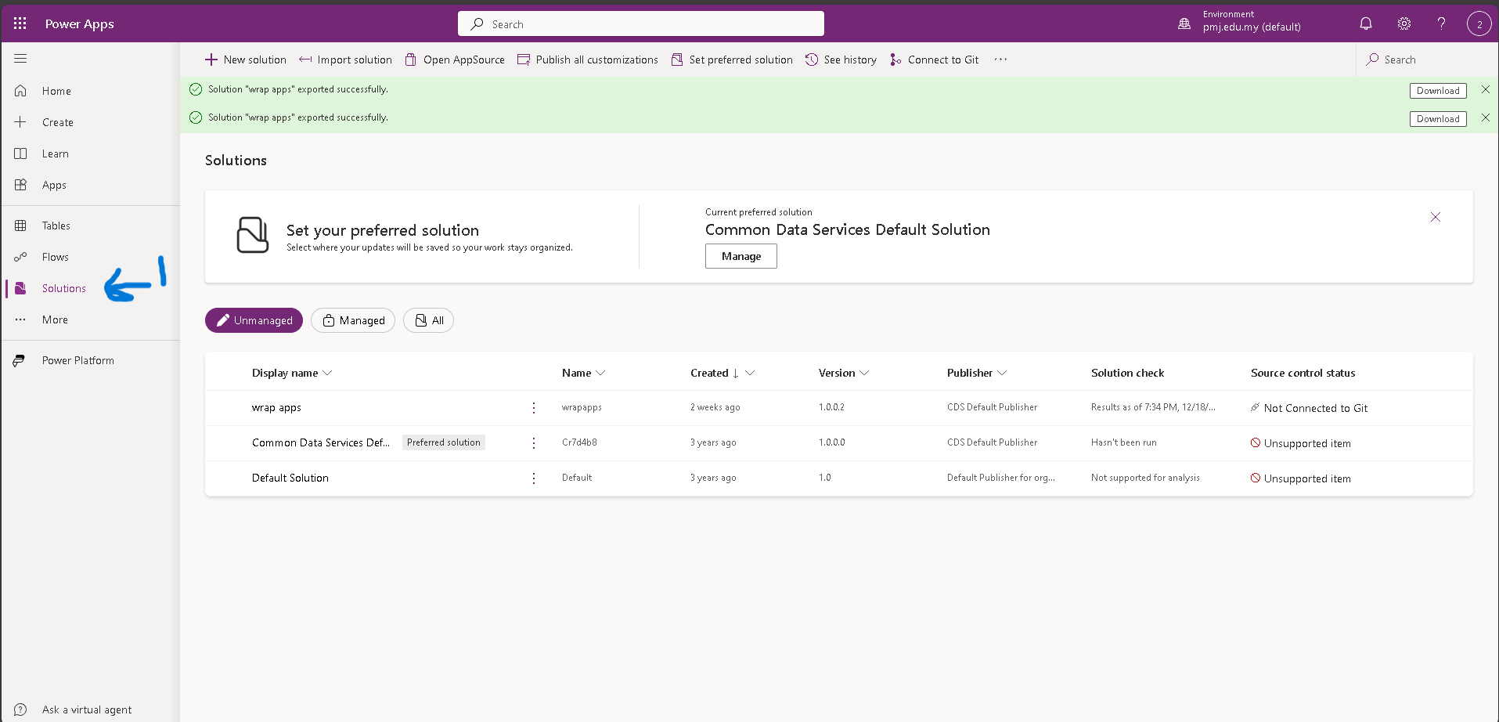

1. Click the import solution tab

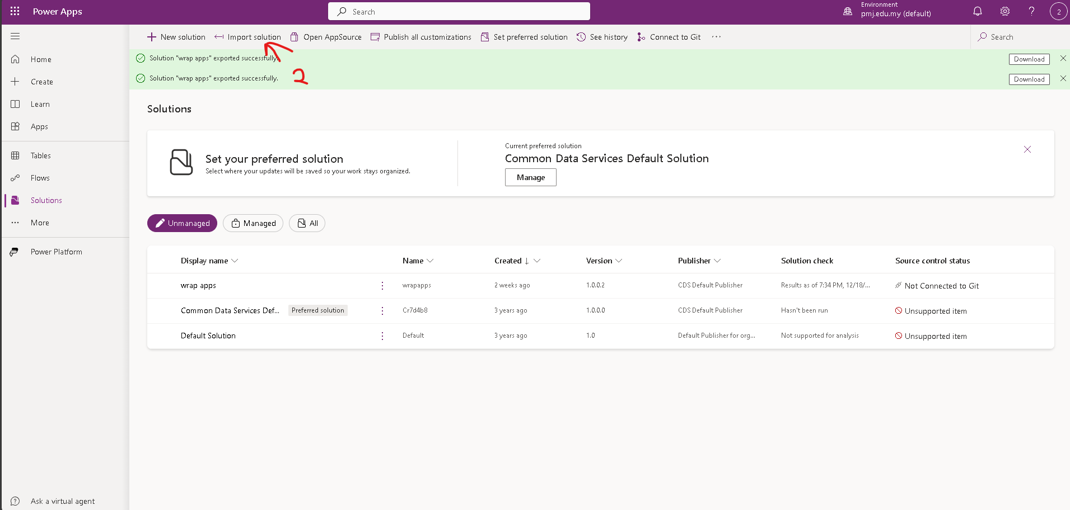

1. Click on the browse button.
2. Select the eCareTrack.zip file and click next button

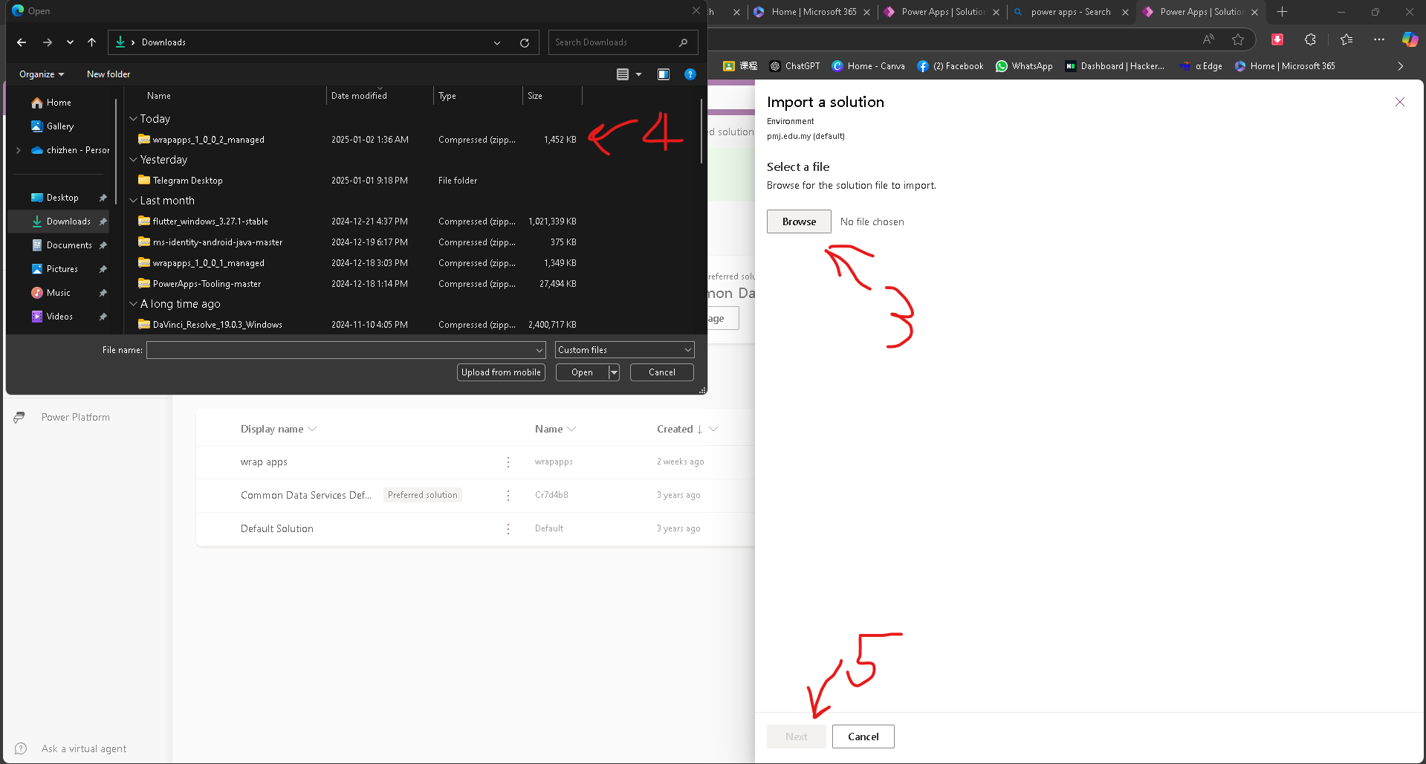

1. Click import

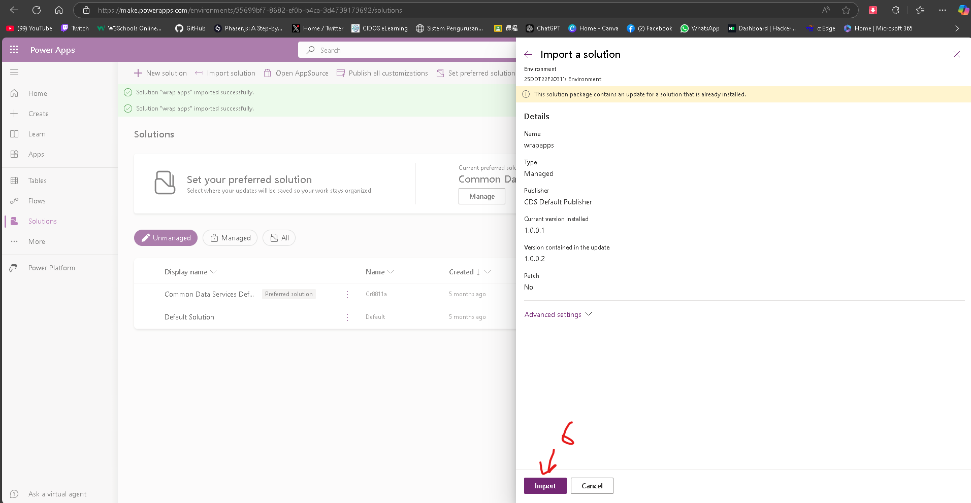

1. It will import the file to the power apps

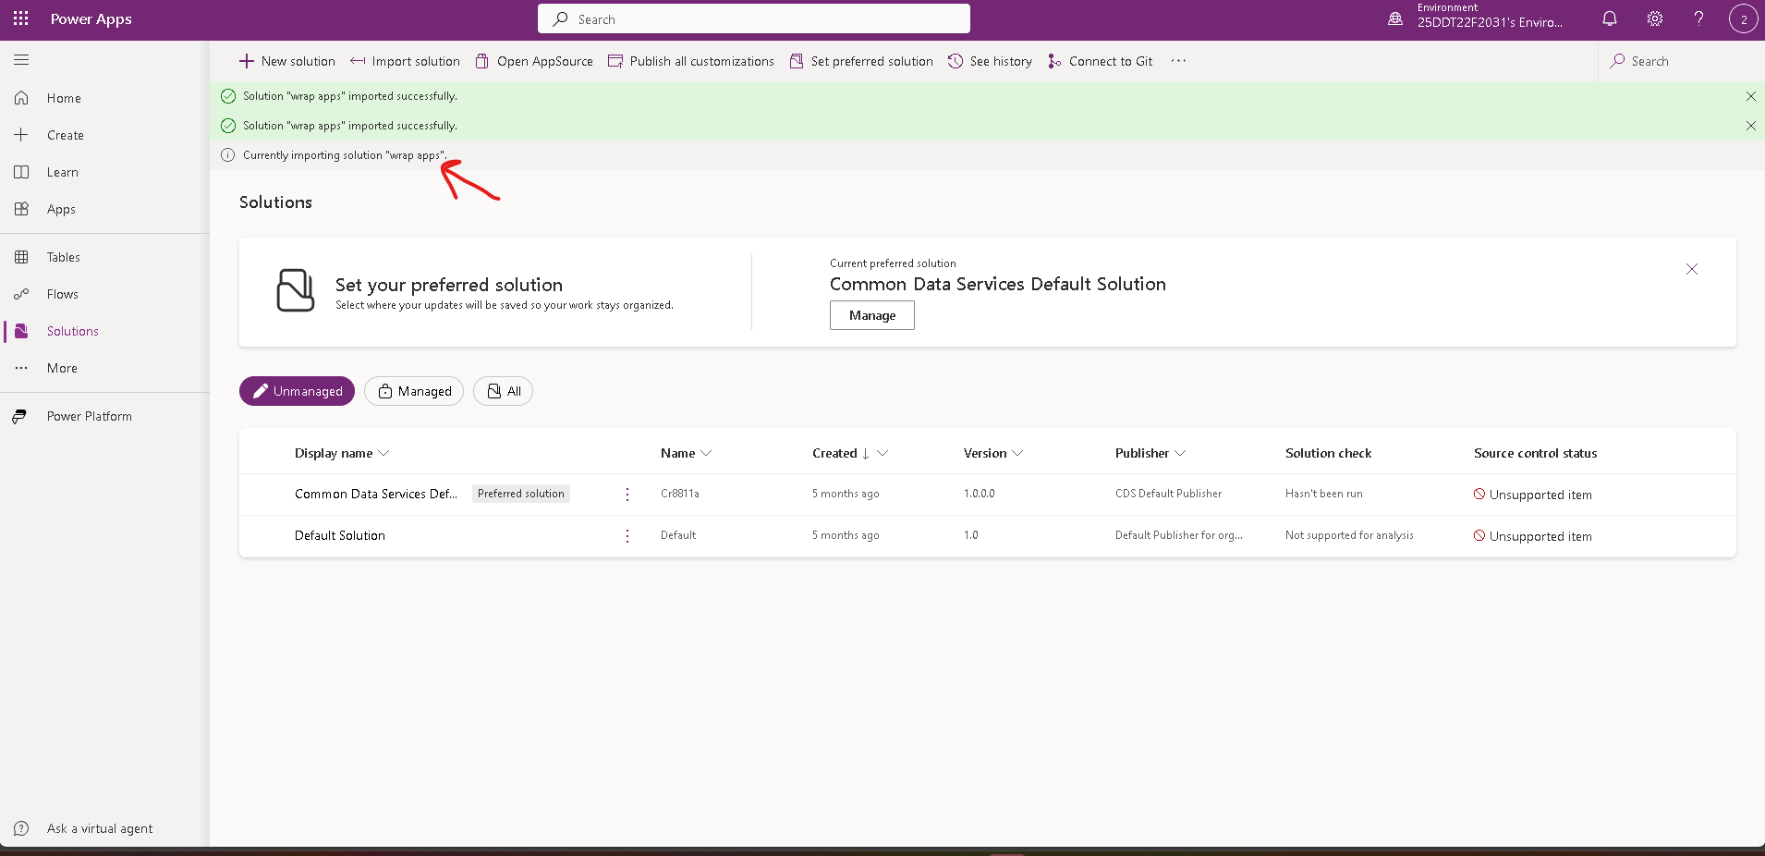

1. If done refresh the web browser and it click on the managed button the file will display in the list

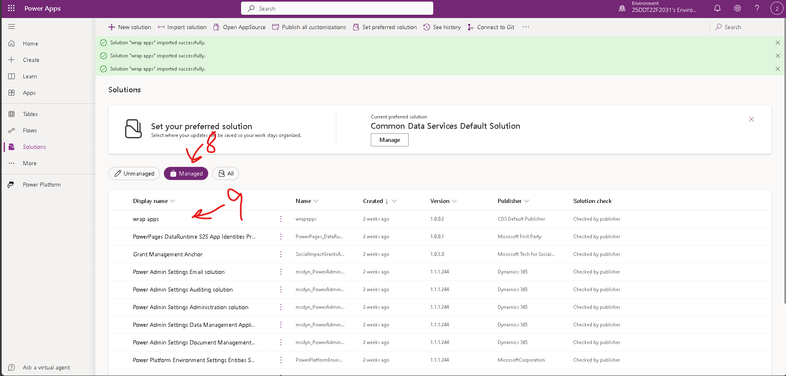

1. Click on the 3 dot and click play

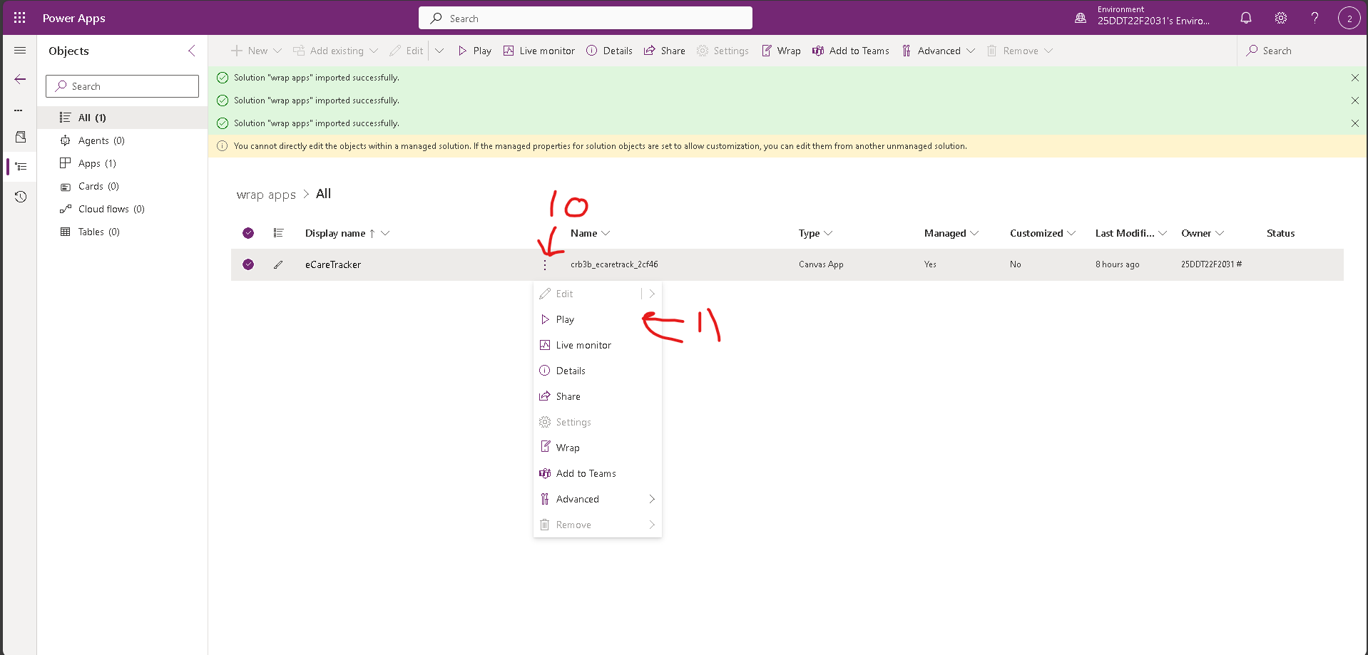

1. The apps will run at another web browser tab

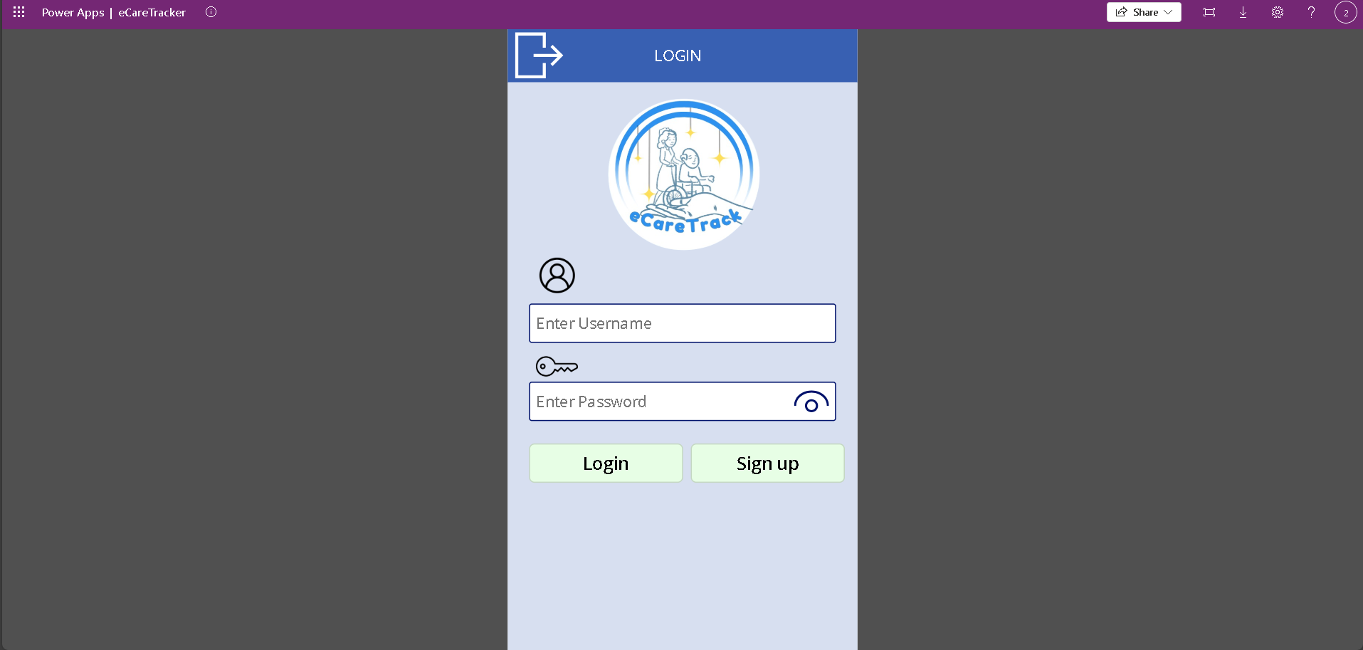

# User Guide

## App Navigation

### Login Page

### If u don’t have the user account. You need to sign up first

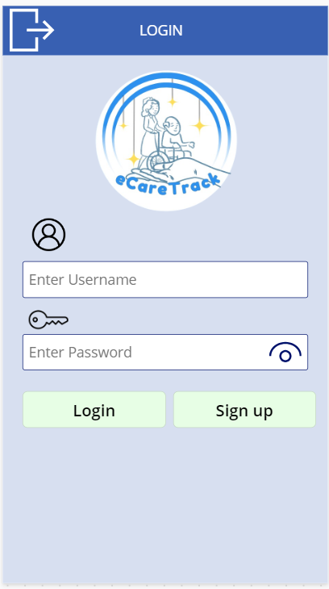

### Sign up page

### type the username, email, and password to create a new user account

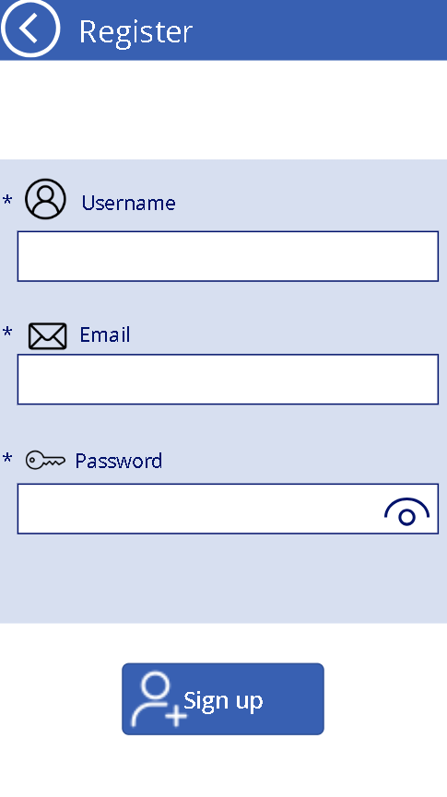

### Homepage

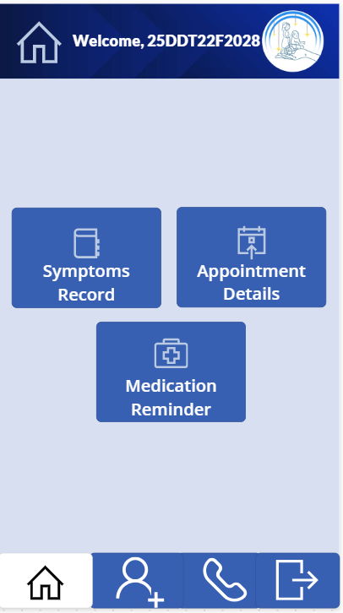

### Patient Page

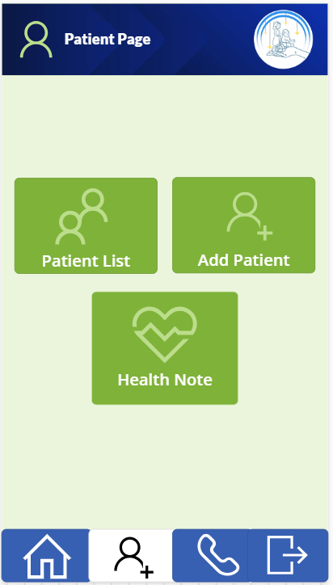

### Emergency Contacts

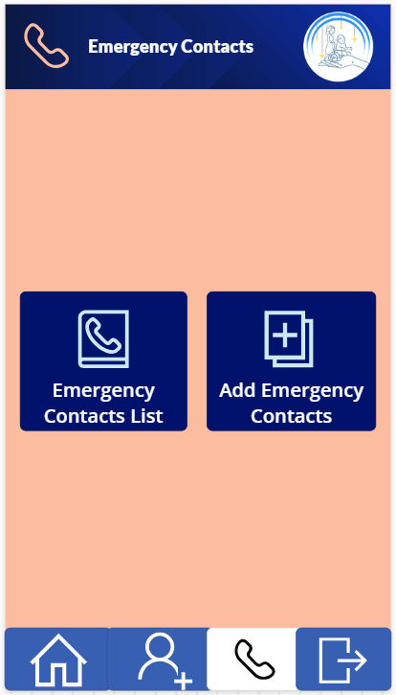

## Using the Features

### How to Schedule Appointments:

1. Click the Appointments tab which is highlighted red in the picture below

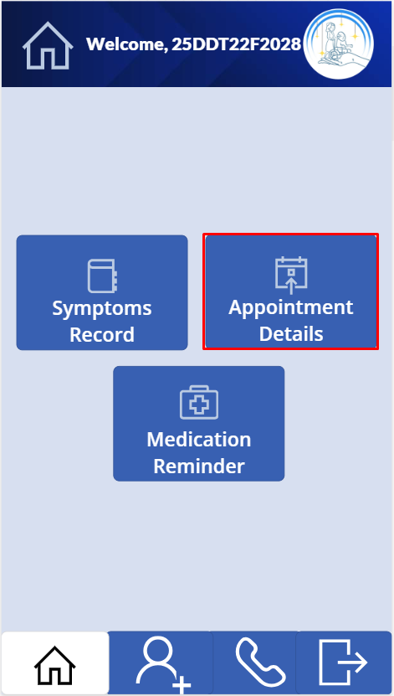

1. Fill in all the information and click submit

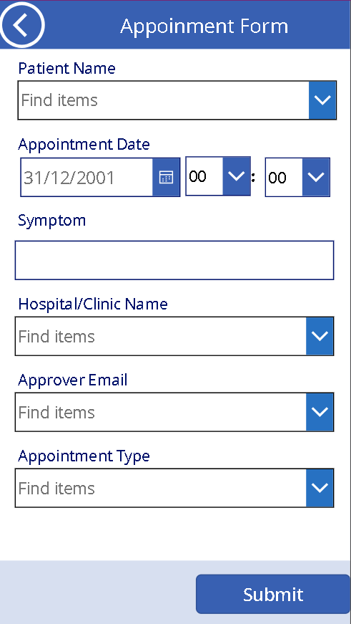

1. It will navigate to the submit successful screen to show your form is successful submitted

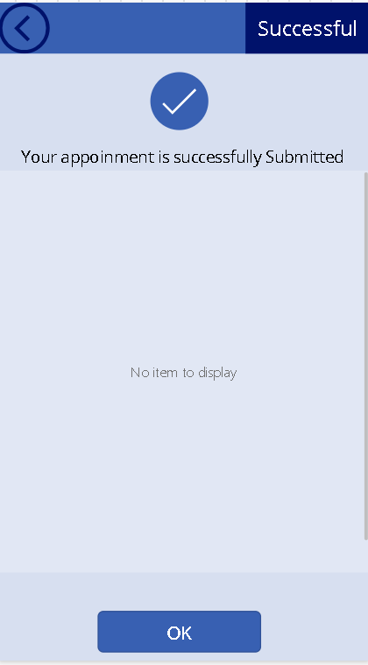

### How to set Medication Reminder:

1. Go to the Medication tab.

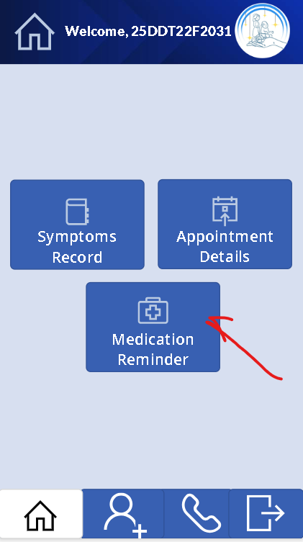

1. Click the add icon button

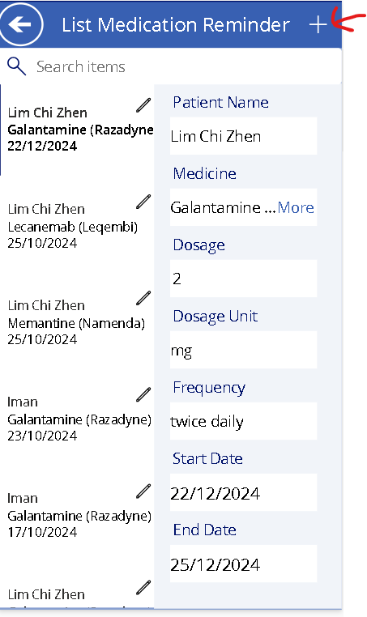

2. Add the name, dosage, and frequency.

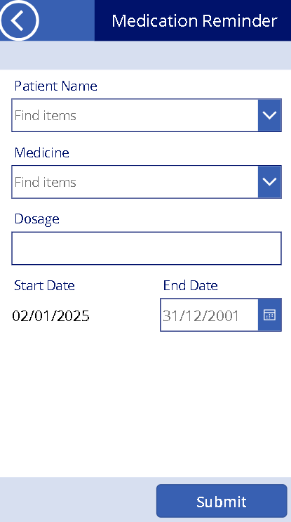

1. Save the reminder.



### How to check/add patient List:

1. On the main page screen click on the button people icon. It will navigate to the patient screen
2. Click on the patient list tab

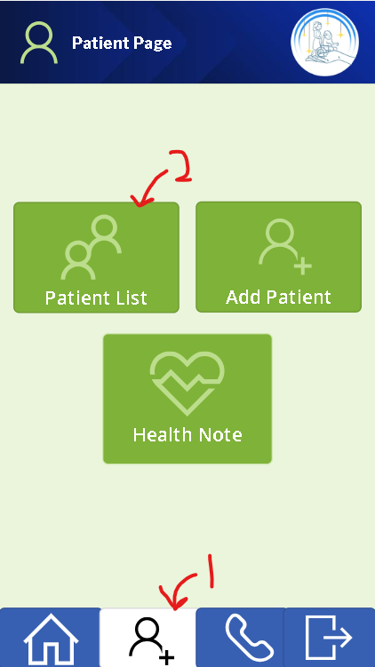

1. It will display the patient list and click on the right arrow icon. It will display the details for this patient.

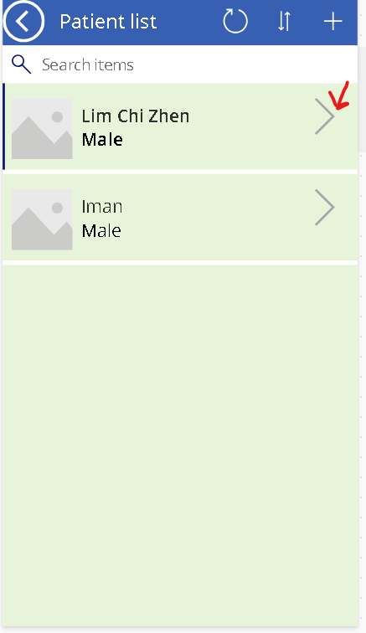 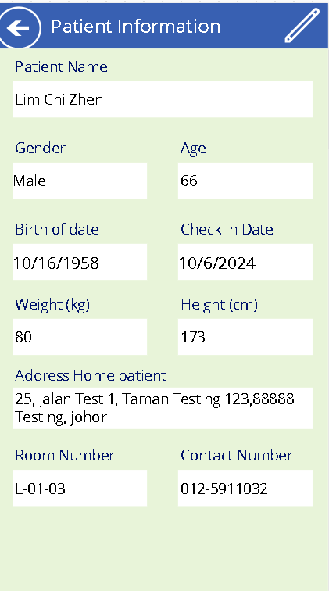

* Add patient

1. Click on the add patient tab or go to the patient list page and click on the add icon

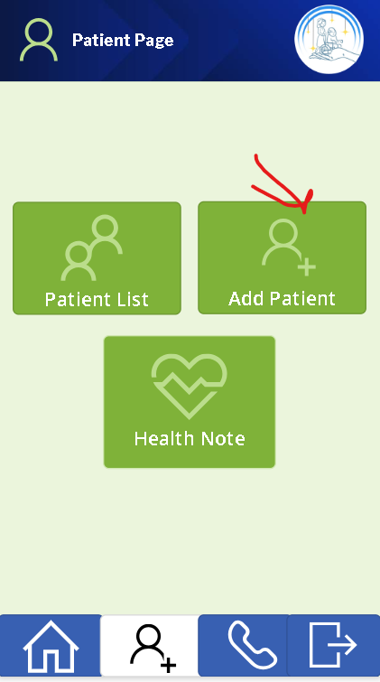 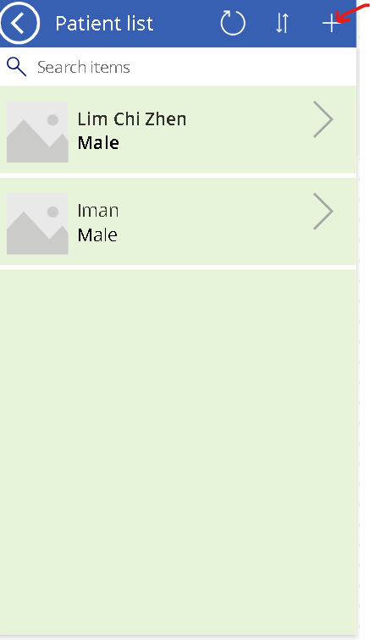

1. It will navigate to the add patient form. Fill in all the information about patient.
2. Next click the right icon button to submit the form to save the information patient

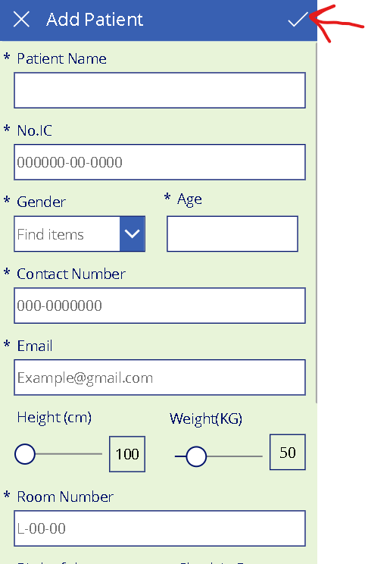

### How to check/add Health Note:

1. Click on the health note tab

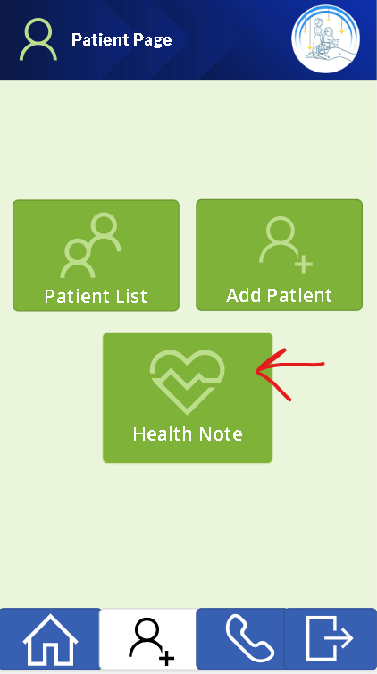

1. It will display the health note list and click on the right arrow icon. It will display the details for the health note.

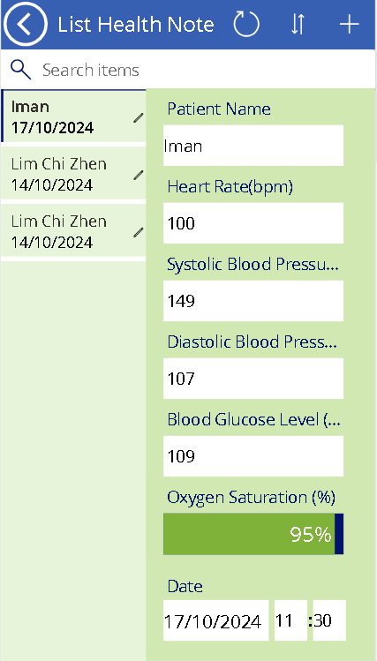

* **Add health note**

1. go to the health note list page and click on the add icon.

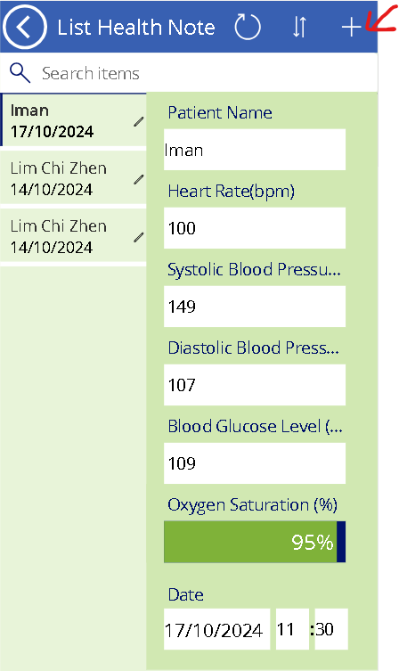

1. It will navigate to the add health note form. Fill in all the information about patient’s health note.
2. Next click the right icon button to submit the form to save.

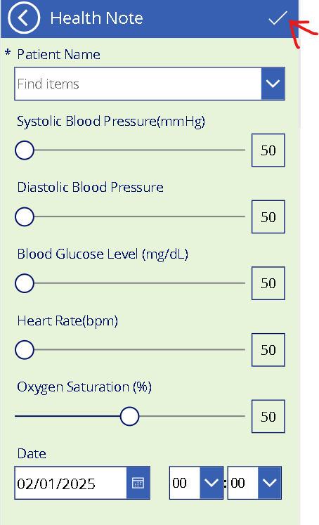

### How to check/add emergency contact:

### How to check/add patient List:

1. on the phone icon button. It will navigate to the emergency contact screen
2. Click on the Emergency Contact List tab

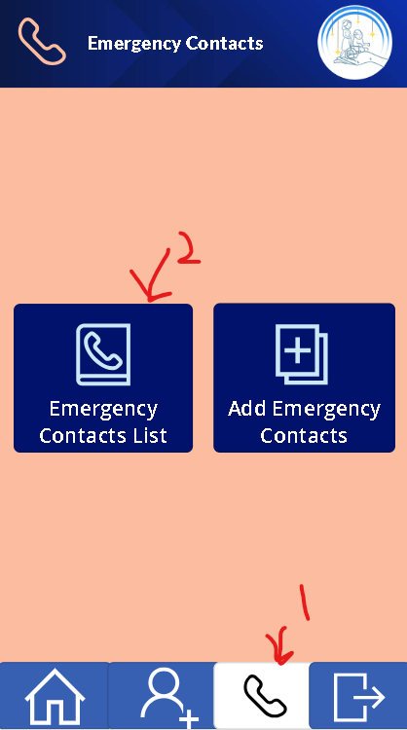

1. It will display the Emergency Contact list and click at the right-hand side It will display the details of the Emergency Contact list.

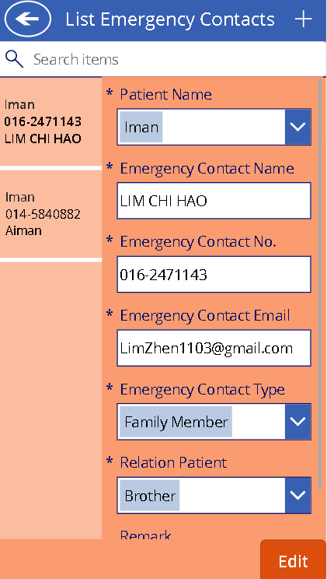

* Add patient

1. Click on the add Emergency Contact tab or go to the Emergency Contact List page and click on the add icon

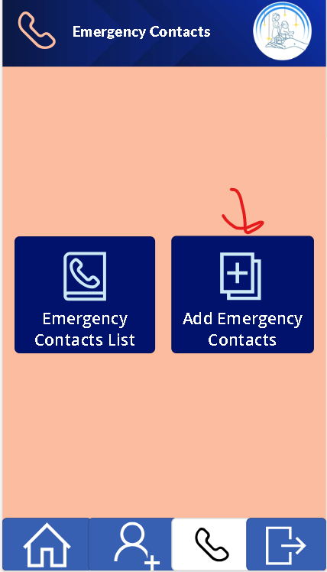 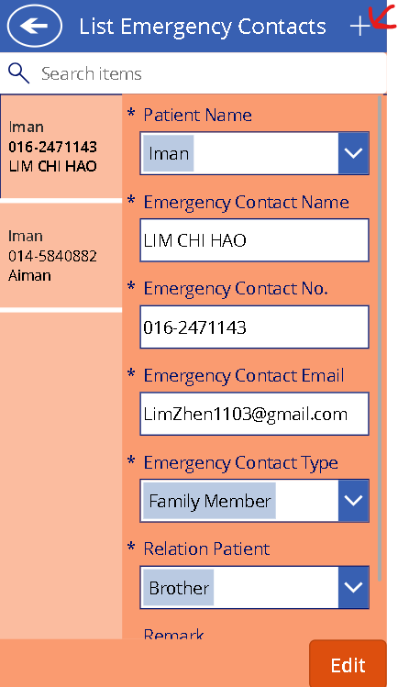

1. It will navigate to the add Emergency Contac form. Fill in all the information about patient’s Emergency Contact.
2. Next click the right icon button to submit the form to save the information patient.

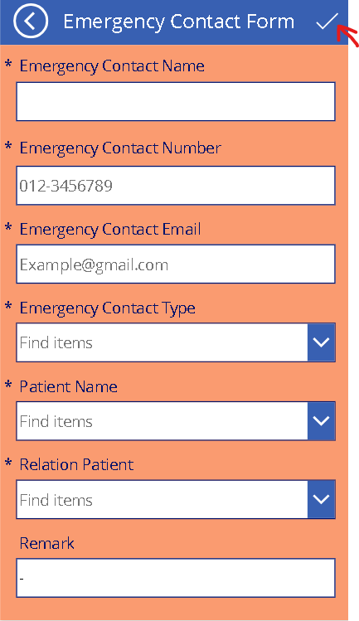

### How to go to the admin panel:

1. Go back to the login page and fill in the username: admin and password: 123 to login to the admin panel

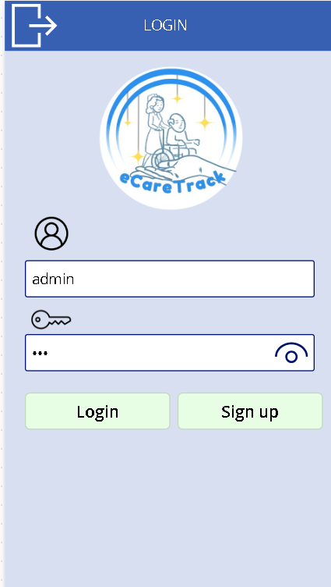

1. It will go to the admin panel

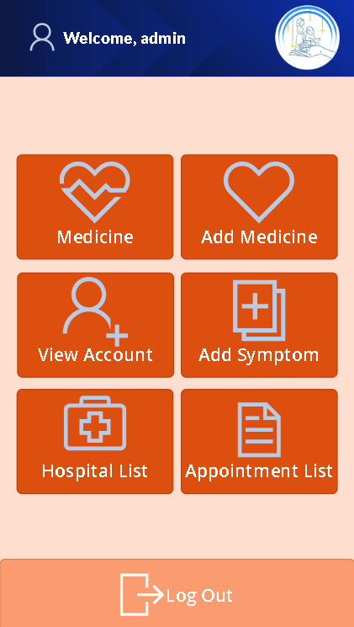

# Troubleshooting

## FAQ

Q: What permissions are required?

A: The user must have access to the Power Apps environment and SharePoint lists.

Q: Can I modify the app?

A: Contact the admin to import the unmanaged solution.

## Contact Information

* Phone Number:
  + +6014-584-0882 (Aiman)
  + +6012-5911032 (Lim)
* Email:
  + [Chizhen2001@gmail.com](mailto:Chizhen2001@gmail.com)